**LAB 9 DELIVERABLES EDUARDO ZUECK GARCES**

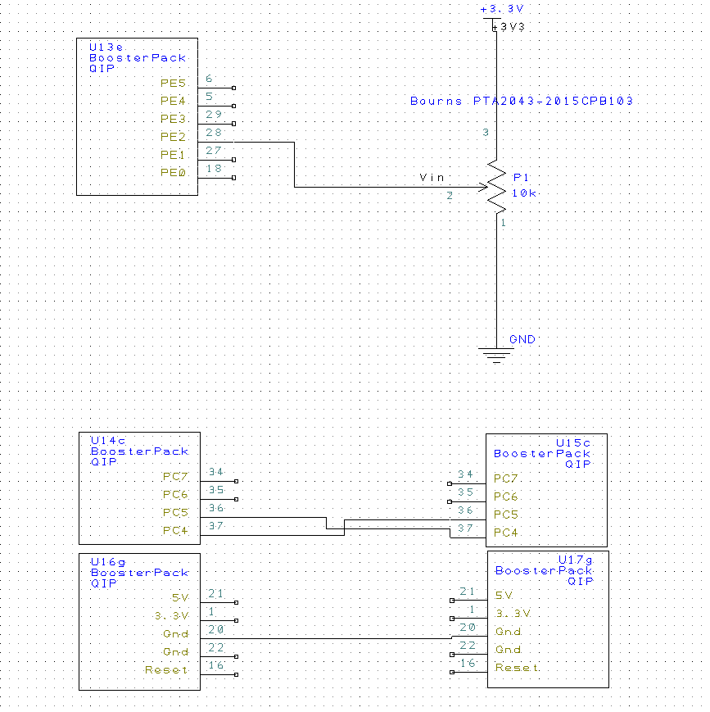**PCB Artist Diagram**

**Oscilloscope**



